**Design Idea 1 – Stacked Histogram/Bar Chart**

As we have seen in the data, one of the most important visualization information is whether the state is won by “Republic”, “Democratic” or “Independent” each year. Thus, we can visualize the shift in the data for each year and by Total Electoral Votes (Percentage) for each of the types of parties. It will look something like Fig. 1 below. Here, Y-axis represents the percentage of votes won by each party (in each state if we are brushing through multiple), X-axis depicts different years. For each year, we will have 3 bars (for each of the Democratic, Republic, and Independent). Each bar will be colored according to the color scale. If we brush through more states, a new chart will be added for every new state added. As we brush through years, more data on X-axis will be added to each chart. This Visualization here is good for seeing the overall general trend for a state or on global scale. A limitation here is that if number of years grows very large, it will become hard to visualize the trend on first look. Also, it lacks in comparing one state to other.

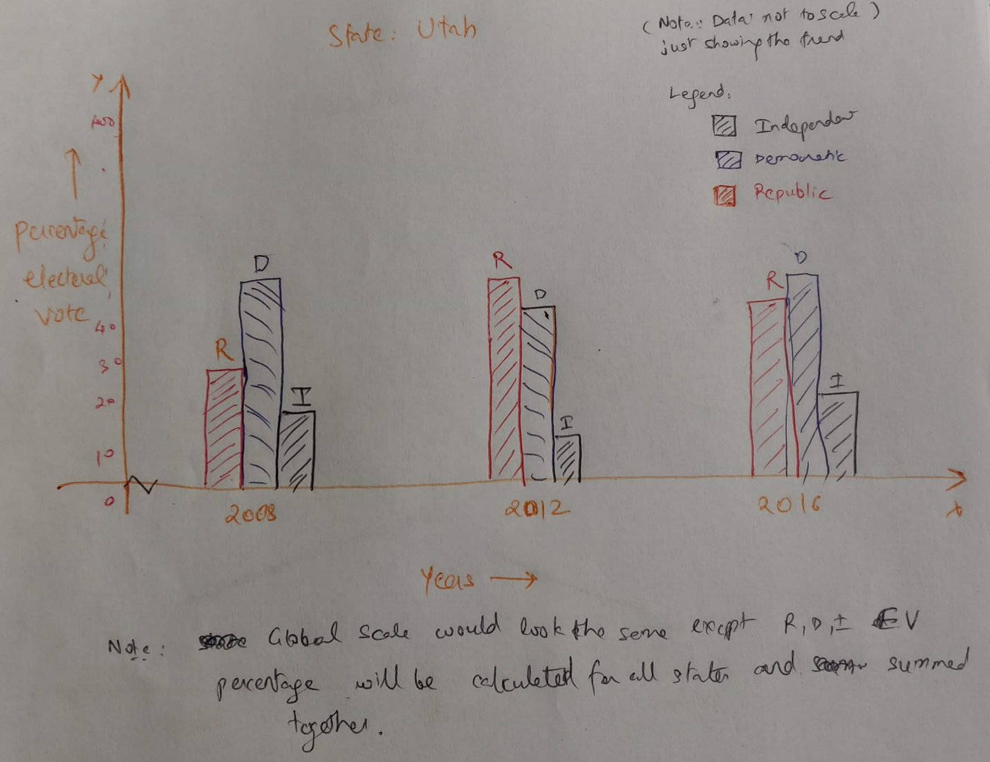

**Design Idea 2 – Two-Sided Bar Chart**

In the two-sided chart, the right side will represent the republican vote percentage and left side will represent the democrats vote percentage. Since, independent vote percentage is usually very small, we can just represent it using a small bar overlaying on democratic or republican side. On the vertical line, we will have years selected through brush. Each year will show the brushed states as individual bars grouped together. Similar thing follows for the democratic side. As we brush through more states and years, more data is added and visualized on the vertical axis. Here, we will create colorScales which will be linear to the democratic blue and republic red color. Each bar will be represented based on the number of votes won and color will be decided based on the color scale. This visualization aids in understanding the trend of votes between different states over time. 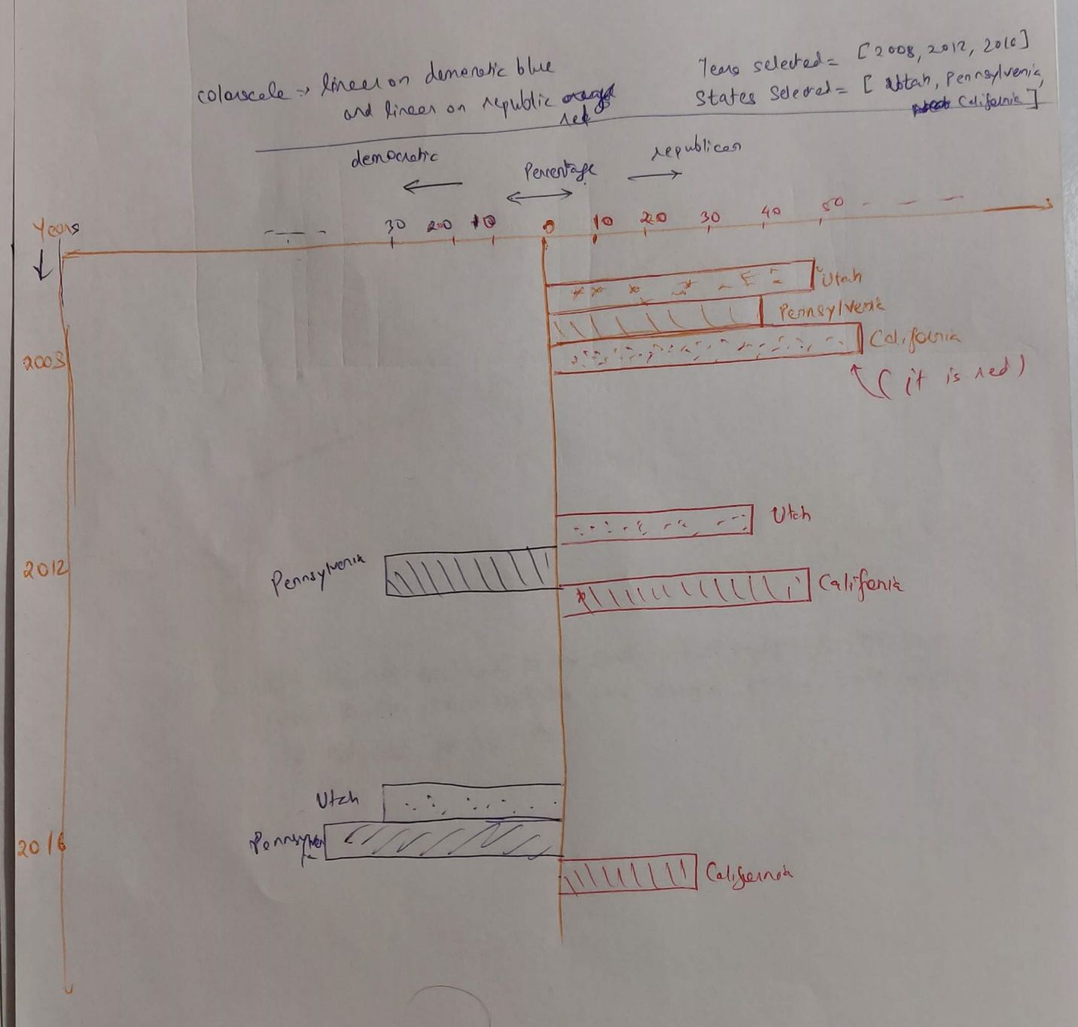

**Design Idea 3 – Line Chart**

Like previous idea we will represent the percentage of electoral votes won by each party through a line chart. Here, we will have three lines (orange, blue, and green) to represent the trend of percentage of electoral votes over different years. Y-axis represents the percentage of votes won by each party (in each state if we are brushing through multiple), X-axis depicts different years. As we brush through years, more data on X-axis will be added to each chart. This visualization aids in understanding the trend of votes and facilitates much better inferences even if the number of years are a lot.

